Colleen Cousins

1337.002

Programming Review

1) **Instructions:**

Program #1: An online shopper program

Answer the questions and statements that the program displays. You will input the price of the item, number of items being bought, the first state and its tax rate, and the second state and its tax rate. Then the program will display what you inputted and it will recommend from which state you should purchase from.

Program#2: Display a pattern

User doesn’t have to do anything.

Program#3: Find and fix the errors

User doesn’t have to do anything.

2) **Output Example**

Program#1: An online shopper program

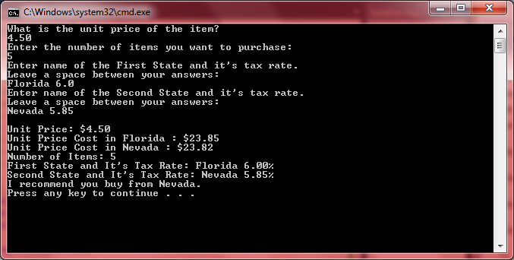

Program#2: Display a pattern

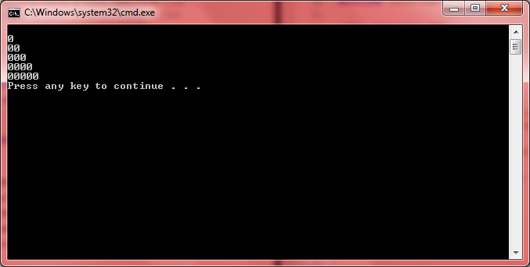

Program#3: Find and fix the errors

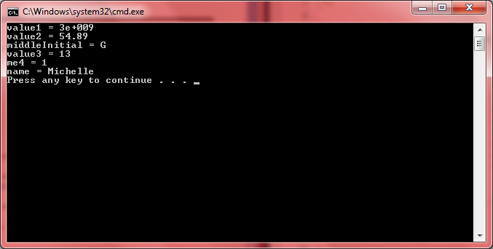

3a) **Questions for Program #3**

**Line 3**: The left brace should be on its own line. This way the main function is easier to read. The program would still be able to run if the left brace was on the same line as the main function. However, for programming style, it is easier for the left brace to be placed on its own line.

**Line 4:** The value assigned to value1 exceeds the data type range for an int data type. To fix this, we can change the data type to a float, which has a much larger range of values than an int.

**Line 5:** value2 and value3 need to be initialized at the beginning of the program. Also, the data type for value2 should be changed to a double instead of staying as an int. This way we can avoid loss of data. On Line 12, the value of capacity is a double. By assigning value2 equal to capacity. This causes the value to be changed from a double to an int. This causes the .89 in 54.89 to be truncated.

**Line 6:** When using a char data type, a character literal are surrounded by ‘ ’ not “ ”. By assigning a char variable with “ “ means that you are attempting to assign a string literal to a char variable.

**Line 7:** Boolean is not a data type name, but bool is. Also 4me is an illegal variable name. Variable names cannot begin with a digit. I just changed the order of the variable name to me4.

**Line 9:** When using a string data type, string literals are surrounded by “ “ not ‘ ‘. Quotation marks allow you to enclose a string of characters.

**Line 15:** When using the = symbol the lvalue has to be a named variable while the rvalue has to be any expression that has value. So value3 and value 13 need to switch places.

**Line 17:** Just change the variable name 4me to me4. This way this variable has a legal name that can be used in C++.

3b)

